***San Francisco Bay Area Rapid Transit District***

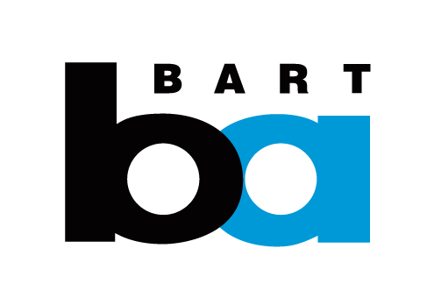 **Now Hiring For Summer and Fall**

**Train Control Electronic Technician**

*Starting pay rate is Step 1: $30.76/Hourly*

***Train Control Electronic Technician***

Ride BART to a satisfying career that lets you BOTH 1) make a difference to Bay Area residents, and 2) enjoy excellent pay, benefits, and stability. BART is looking for people who like to be challenged, work in a fast paced environment, and have a passion for connecting over 400,000 daily riders to work, school and other places they need to go. BART offers a competitive salary, comprehensive health and medical benefits, paid time off, plus CALPERS retirement in the future.

**Minimum Qualifications**

Education: An Associate of Arts/Sciences degree in digital electronic technology or in a closely related field; or completion of an apprenticeship or technical training in digital electronic technology or a closely related field.   
  
Please Note: Applicants with transcripts from outside the United States or its territories must have the transcripts evaluated by an academic accrediting service.

**Other Requirement:**

Must possess a valid California driver's license and have a satisfactory driving record. Must possess adequate color vision to distinguish parts and wiring, physical strength to lift and carry up to 50 pounds and mobility to climb, stoop and crawl to reach work; must be willing to work emergency overtime and off hour shifts.   
  
Desirable: Verifiable experience in the maintenance and repair of electrical, electronic, computer, and electro-mechanical equipment.   
  
Ability to: Rapidly learn specific features of yard control and train control equipment and maintenance procedures at the District.

**To apply online go to** [**www.bart.gov/jobs**](http://www.bart.gov/jobs) 

**Equal Employment Opportunity**

The San Francisco Bay Area Rapid Transit District is an equal opportunity employer. Applicants shall not be discriminated against because of race, color, sex, sexual orientation, gender identity, age, religion, national origin, disability, ancestry, marital status, veteran status, medical condition (cancer-related), genetic information or any protected category prohibited by local, state or federal laws. The BART Human Resources Department will make reasonable efforts in the examination process to accommodate persons with disabilities or for religious reasons. Please advise the Human Resources Department of any special needs in advance of the examination by calling (510) 464-6112.

Qualified veterans may be eligible to obtain additional veteran's credit in the selection process for this recruitment (effective Jan. 1, 2013). To obtain the credit, veteran's must attach to the application a DD214 discharge document or proof of disability and complete/submit the Veteran's Preference Application no later than the closing date of the posting. For more information about this credit please go to the Veteran's Preference Policy and Application link at [www.bart.gov/jobs](http://www.bart.gov/jobs).